**Red Light, Green Light**

For U6 and U8 Players. This drill will focus on dribbling with the ball close in order to stop quickly

[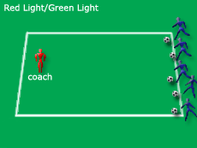](http://www.soccerxpert.com/printdrill.aspx?id=1223)

**Setup**

Create a starting line for each of the players, and the coach should move 15-20 yards away.

**Instructions**

With the coaches back to the players, he yells GREEN LIGHT and the players try to dribble to the coach. When the coach yells RED LIGHT, he waits a moment and then turns to face the players. Anyone who is not stopped has to go back to the farthest person from the coach.

**Variations**

* Have the players dribble with only the right or left foot.

**Coaching Points**

* Make sure the players keep the ball close so they can stop quickly.

**Sharks and Minnows**

This drill focuses on the U6 and U8 player and their ability to dribble out of pressure. This drill can be used to focus on the player using their body to protect the ball by placing their body in between the ball and the defender.

[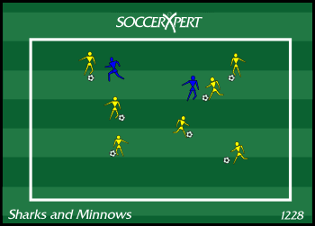](http://www.soccerxpert.com/printdrill.aspx?id=1228)

**Setup**

Build a grid approximately 20X25 yards this field should be adjusted based based on the skill level and number of players participating. Each player should have a ball except for 2 sharks.

**Instructions**

The players with balls (the minnows) attempt to protect their ball from the two "Sharks". The Sharks attempt to gain possession and knock the minnows (ball) out of the grid. Once this happens, the minnow can run around the grid once and return to the game. Each minnow has two changes, and the last 2 minnows remaining become the sharks in the next round.

**Variations**

* Players only use left foot to dribble.
* Players use outside of feet to dribble.
* Players use sole of feet to dribble.

**Coaching Points**

* Keep the dribblers under control and not paniced once the sharks get near them.
* Inform players to keep the ball close within playing distance.

**Ouch!**

This drill should be used with younger players (U6 and U8) to introduce dribbling, looking up and properly striking the ball at a target. AND IT's FUN!

[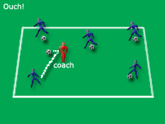](http://www.soccerxpert.com/printdrill.aspx?id=1224)

**Setup**



Build a grid 20X30 (may adjust if too large or small). Every player must be in the grid with a ball.

**Instructions**

The coach jogs around in the grid and players try to kick their balls and hit the coach. The players get a point each time they hit the coach. The coach should yell OUCH eah time they are hit to make the game FUN.', '* Make sure the players are striking the ball with the proper part of the foot.

**Variations**

* If the players are struggling to hit the coach, the coach should stop for a couple seconds to give the players a chance.
* Use different parts of the foot: Inside, Instep, Right and Left foot.

**The Soccer Gauntlet**

The primary focus of THE SOCCER GAUNTLET is centered around good dribbling technique in traffic which requires vision and awareness.

[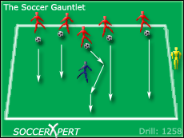](http://www.soccerxpert.com/printdrill.aspx?id=1258)

**Setup**

Make a grid approximately 20x15 yard. Instruct one defender to stand inside the grid without a ball. The remaining players will start on the end line with a ball.

**Instructions**

On the coach’s command, all of the attacking players dribble at speed to the other side line avoiding the defender. If the defender wins the ball and kicks the ball out of the grid, that attacker becomes an additional defender (without a ball) on the next series. The last player to make it through the gauntlet wins the game.

**Variations**

* Limit the foot the attacker can dribble with

**Coaching Points**

* Keep the ball close to the dribbler  
* Stay in control of your body and ball   
* Keep your eyes up to avoid pressure  
* Dribble into space avoiding pressure  
* Dribble with speed when in open space

**HItters and Dodgers**

The Hitters and Dodgers soccer drill is a great warm-up and drill for younger players under 5 through under 9. This soccer drill is great for teach players to dribble and then getting their heads up to make a pass. This soccer drill is SO much fun and the younger age group players LOVE this soccer drill.

[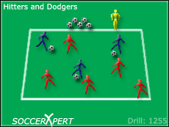](http://www.soccerxpert.com/printdrill.aspx?id=1255)

**Setup**

With disk cones, outline a grid that is about 15X15 yards. You might want to make it a bit bigger or smaller depending on the age and number of kids you have. You will need to have a ball for each player; however, only 3 players start off with balls. The remaining balls should be placed outside the grid. The three players with balls are called the "hitters". The remaining players should start off scattered throughout the grid they are the "dodgers".

**Instructions**

Instruct the "hitters" to dribble inside the grid and attempt to pass the ball to any of the "dodgers" and hit them with the ball. The "dodgers" are attempting to avoid being hit by the "hitters". If a "dodger" is hit, he must collect a ball from the extra balls outside the grid and join the hitters. The last players standing win.

**Variations**

None

**Coaching Points**

Coaches should talk to the hitters about keeping their ball close to the while getting their heads up to find the dodgers.  
Coaches should focus on good passing form: using the inside of the foot with good pace on the ball.

**Coach’s Revenge**

Drill Rating 3.88 from 45 user votes. Viewed 85964 times.

This drill is designed to be a fun soccer drill. It will focus a bit on young player’s agility while dodging balls kicked at them, and is a great ice breaker or a fun warm-up game at the beginning of practice.

[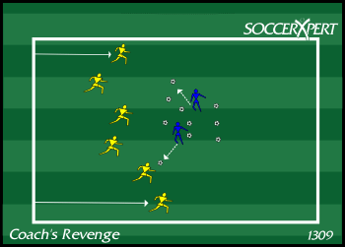](http://www.soccerxpert.com/printdrill.aspx?id=1309)

**Setup**



Create a grid approximately 25X30 yard grid (the size of the grid can be adjusted depending on the age and number of players). Have all of the teammates spread out on one of the end lines without a ball. The coach or coaches should be in the middle of the grid with every ball.

**Instructions**

On the coach’s command, every player must sprint from one side of the grid to the other while avoiding balls being knocked at them by the coaches in the middle. The Coach attempts to hit the players as they pass from the knee down.

If a player is struck by the coach’s pass, those players collect the balls and join the coach’s in the middle of the grid attempting to hit the remaining players.

The last player standing wins!

**Variations**

N/A

**Coaching Points**

* Players must sprint from one side of the grid to the other.
* Players should lift their head to avoid being struck with the ball.
* Encourage players to have fun!

**Pirates of the Pugg**

This soccer drill is a great soccer drill using a [Pugg Goal](http://www.soccerxpert.com/pugg-goals.aspx) that can be tweaked to focus on many aspects of the game. For younger players ages 8-11, the primary focus should be on good dribbling technique in traffic which requires vision and awareness. The coach can also focus on transition from offense to defense if the ball is lost, or recovering from a tackle and finding safety. Defensively, this allows defenders to steal the ball from attackers and play to a particular goal or target.

[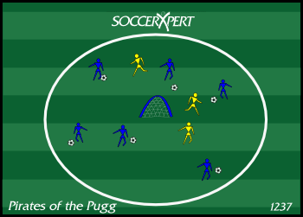](http://www.soccerxpert.com/printdrill.aspx?id=1237)

**Setup**



Build a circle approximately the size of the center circle with a [Pugg Goal](http://www.soccerxpert.com/pugg-goals.aspx) in the middle of the circle. The actual size of the circle will vary depending on the age and skill level of the players. With all players in the playing area, dedicate 9 players with the ball, and 3 players without a ball will be the "Pirates".

**Instructions**

Instruct the "Pirates" without the ball to defend the players with the balls. Once the Pirate wins the ball, they attempt to score on the [Pugg Goal](http://www.soccerxpert.com/pugg-goals.aspx) in the middle of the circle. If the Pirate scores the goal, that player too becomes a Pirate. Play continues until the last player with the ball wins. If the pirates have a hard time getting started, the coach can help the pirates at first.

**Variations**

NONE

**Coaching Points**

**Attacking:** keep the ball close with head up so the players are aware of defenders and safety areas (space). If the ball is lost, recover quickly and fight to win it back.   
**Defending:** Transition quickly from defense to offensive and stay focused once the ball is won, and find the target.

**Simon Says**

For U6 and U8 players. This drill focuses on dribbling and keeping close control for quick instructions. Also works on listening skills for the younger player.

[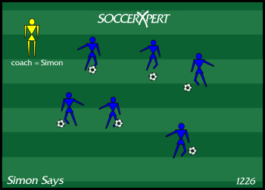](http://www.soccerxpert.com/printdrill.aspx?id=1226)

**Setup**



Outline a 20X30 grid with cones. Each of the players need a ball.

**Instructions**

Play Simon Says with the team as the players dribble in the grid. If a player does something they are not supposed to, issue them a GOTCHA. See who gets the least number of GOTCHA's. Examples of commands could be: Change direction, stop the ball, stop the ball and put your belly on the ball... etc. Also, try to throw in a trick or two like: kick the ball as far away as you can.

**Variations**

* Without ball
* With ball in hand
* With ball

**Coaching Points**

* Have players do actions like clapping in between their legs and skipping to increase body awareness.
* Focus on dribbling skills and keeping the ball close and under control.
* Focus on players listening skills.

**Knock Out**

This drill is a great warm-up drill for dribbling sessions. It emphasizes on dribbling and ball control (keeping head up, change of direction and change of pace).

[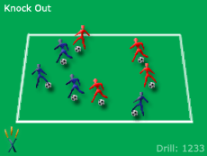](http://www.soccerxpert.com/printdrill.aspx?id=1233)

**Setup**

Create a grid depending on the number of players and have each player with a ball inside the grid.

**Instructions**

Instruct the players to protect their own ball while trying to "knock out" the other player's balls out of the grid. Players must stay with their ball and cannot leave the ball for long periods of time. Players can only be "knocked out" 2 times where they do 5-10 pushups and get back in the game. On the 3rd time, they are out.

**Variations**

* Make players dribble with certain parts of their foot.
* If player dribbles out of bounds their self they are considered "knocked out".

**Coaching Points**

* Instruct players to keep the ball close and touch the ball often * Players heads should be up looking for other players and be aware of their surroundings

**The Numbers Game**

This drill focuses on the 1v1 situational play for younger players. This focuses on the individual dynamics of this game such as dribbling, shooting, shielding, turning and beating an opponent.

[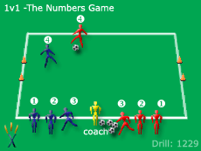](http://www.soccerxpert.com/printdrill.aspx?id=1229)

**Setup**



Create a small 1v1 field approximately 15X20 with two small goals on each endline. Split the group into two even teams and assign a number to each player in each group. For instance if you have 5 players in each group, number off 1-5 in each group. One group should wear alternate jerseys.

**Instructions**

The coach will play a ball into the area and call out a number. Those players must then sprint onto the field and play a 1v1. The game should continue until a goal is scored or the ball goes out of bounds.

**Variations**

* Have more than one 1v1 going at the same time.
* Call out two or more numbers to create a 2v2 or 3v3.

**Coaching Points**

* Encourage players to take on their opponent.
* Encourage players to shoot when they have a chance of a goal.
* Instruct the players to protect the ball when necessary.

**1v1 to Multiple Goals**

This soccer drill is great drill for focusing on teaching players attacking skills such as taking on their opponent or learning to attack space. Defensively it will teach players the responsibility of man marking.

[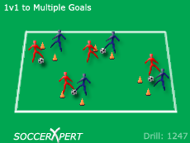](http://www.soccerxpert.com/printdrill.aspx?id=1247)

**Setup**



Make a 40X40 grid. Split your team into pairs with one ball per pair. Randomly set up small goals (approx 2-3 yards wide) with flags within the grid; one goal per pair. Each pair should begin at their window.

**Instructions**

Each team will play 1v1 using their goal only. Goals are scored by dribbling across the goal line. Goals can be scored from either side of their own goal. Players play 1 to 2 minute games and rotate players.

**Variations**

Open it up where each pair can score on any of the other goals. They are still paired up with only their partner and should not interfere with any other pairs going on. Goals can still be scored from either side of the goals by dribbling through the goal.

**Coaching Points**

**Attacking:** Head up and aware of other players, change of direction, close control, and change of pace **Defending:** Bent Knees, aware of attacker, tracking attackers movement and protecting the goal

**Guard the Castle**

This drill is a great small sided game that focuses on passing in numbers up situations This is a fun drill and the kids will love it!

[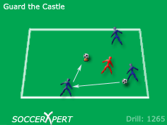](http://www.soccerxpert.com/printdrill.aspx?id=1265)

**Setup**



Set up a grid that is 12 X 12 yards. Organize the team into groups of four. One of the four players should wear an alternate jersey and be the designated defender (guarder of the castle). Take a ball and place it on the top of a disc cone in the middle of the grid, this will become the “castle”. If you do not have disc cones, a tall cone will work just as good.

**Instructions**

It will be up to the 3 attackers to pass the ball around the defender in the grid in attempt to knock down the castle with a pass. The castle is considered knocked down when the ball is knocked off the cone or the tall cone is knocked down with a pass.

**Variations**

* Depending on the age level and skill of the players, you can remove the 12 x 12 grid limitations, or make the grid smaller for very skilled players.
* If players are standing next to the cone, you can build a 3x3 grid and not allow players to step into that small grid.
* Require players to complete a certain number of passes before they are allowed to knock down the castle.
* Play 1v1 and focus on dribbling skills.

**Coaching Points**

* Instruct players to get their heads up to find the pass.
* Make sure the players are passing the ball with proper weight on the ball.
* Make sure players are moving about the grid in order to find open space. Make sure players know it is ok to dribble the ball to space or beat the defender before making the pass.
* Make sure players are making the easiest decisions when passing.

**1v1 50/50 to Goal Team Competition**

The purpose of this [soccer drill](http://www.soccerxpert.com/drills.aspx) is to work on [soccer fitness](http://www.soccerxpert.com/soccer-fitness-drills.aspx), [scoring soccer goals](http://www.soccerxpert.com/soccer-attacking-drills.aspx), [soccer shooting](http://www.soccerxpert.com/soccer-shooting-drills.aspx), [soccer goalkeeping](http://www.soccerxpert.com/soccerdrills/1v1-to-Goal-Team-Competition.aspx), and winning 50-50 balls. This is a [fun soccer drill](http://www.soccerxpert.com/fun-soccer-drills.aspx) for the younger soccer player.

[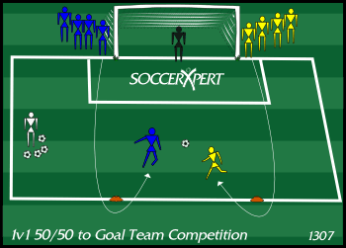](http://www.soccerxpert.com/printdrill.aspx?id=1307)

**Setup**



On a [full size training goal](http://www.amazon.com/gp/product/B001C1YJSU?ie=UTF8&tag=soccerxpert-20&linkCode=as2&camp=1789&creative=9325&creativeASIN=B001C1YJSU)http://www.assoc-amazon.com/e/ir?t=soccerxpert-20&l=as2&o=1&a=B001C1YJSU, place a goalkeeper in the goal. Split the remaining players into two even teams and align them on each goal post. The first player in line must start with one hand on the goal post.  A cone should be placed approximately 20 yards from goal in front of each line. The coach should have a supply of soccer balls available.

**Instructions**

On the coach’s command, the first player from each team should sprint around the cone in front of their line. As the players approach the cone the coach should play a 50/50 ball in the middle of each cone. The two players should battle for possession and quickly attack the goal.   
  
The players should battle each other for the ball and either player can score a goal once possession is won. As a goal is scored the team scoring the goal is awarded a point.   
  
First team to 10 wins.

**Variations**

* N/A

**Coaching Points**

Players should be instructed to:

* Sprint at top speed around the cone
* Battle and win the 50/50 ball
* Quickly attack the goal once possession is won.
* Continue to fight for the ball when defending.
* Have fun.

**Dribbling warmup**

This soccer drill is a great warm-up drill that allows players to work on touching the ball with all parts of the foot. If you want to improve players footwork and dribbling skills this is a good start to each practice.

[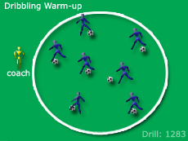](http://www.soccerxpert.com/printdrill.aspx?id=1283)

**Setup**



Either use the center circle of the field or build you a circle with cones. Each player needs to have a ball and start inside the circle.

**Instructions**

1. Have players dribble anyway they want inside the circle as long as they are using both feet for 2 minutes.
2. Have the players juggle for 1 minute using feet only trying to alternate from right to left.
3. Have players dribble with inside and outside of each foot with the following pattern: right foot - inside, outside, inside, outside then switch to left foot inside, outside, inside, outside and continue to switch feet. Do this for 2 minutes.
4. Have players juggle with their thighs and feet for 1 minute. Again instruct players to switch feet while juggling.
5. Have players work on cuts and turns. The players should be instructed to cut the ball quickly and have a short sprint after cutting or turning the ball. Make sure players are exploring with inside and outside of the foot cuts and staying with the ball when they cut. Do this for 2 minutes.
6. Now instruct the players to juggle again. This time juggle with the feet and pop the ball to the chest and back down to the feet. Do this for 1 minute.
7. Now have players turn the pace up a notch and play full speed working on cuts, turns, and avoiding collisions. Push players to work hard for 1 minute straight.

**Variations**

N/A

**Coaching Points**

* Make sure the player is constantly lifting their head and checking their surroundings. This will help players find space and avoid other players.
* Make sure players keep the ball close to them while in congested areas. This will help them move the ball more quickly to avoid other players and obstructions.
* Encourage players to use all parts of their feet while dribbling (inside, outside, top, bottom).

**Four Corners Aggressiveness and Fitness Drill**

This soccer drill focuses on aggressiveness in winning 50/50 balls and fitness. This drill will be more beneficial for players under 8 and older.

[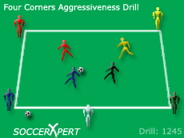](http://www.soccerxpert.com/printdrill.aspx?id=1245)



**Setup**

Create a grid that is 30x30 yards. Create 4 teams and have them stand at each of the four corner cones. The coach stands outside the grid near the middle of 2 side cones with a large supply of soccer balls.

**Instructions**

The coach plays a ball into the center of the grid and shouts out a command (such as “GO”) to begin play. The first player in each of the 4 lines must sprint after the ball in attempt to reach the ball first. Once the ball is won cleanly, the player must hold possession from the other players for 5 seconds before passing the ball back to the coach. If any player steals the ball from the person in possession, that player will then attempt to hold possession for 5 seconds. A team scores a point by successfully holding possession for 5 seconds and making a return pass to the coach. The first team to reach 5 points wins.

**Variations**

* The coach can play different types of balls such as flighted balls, bouncing balls, rolling balls, balls with large amounts of top or back spin.

**Coaching Points**

* Players should be taught to go after the ball aggressively with speed, determination and vigor.

**2v2 Challenge**

This soccer drill focuses on putting players in 2v2 situations while attacking the goal. The dynamics of the games works on transitioning and fitness and demands on the players can be intense at times.

[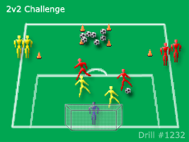](http://www.soccerxpert.com/printdrill.aspx?id=1232)

**Setup**



Start the soccer drill by splitting the group into two teams with a keeper in goal. Place two cones approximately 20-25 yards from goal about 30 yards apart. Instruct one team to line up behind one cone and the other team line up behind the other team (don't worry about lines because the players will be involved very quickly). Create a 5 X 5 yard box about 10-15 yards past the two cones, and place all the balls in this box.

**Instructions**

Have 2 players from each team enter the playing area. Each team will play 2v2 to goal as normal. However, the dynamics of the game begin when you introduce the two rules.   
  
RULE 1: If a players shoots and the keeper saves it, or the shot misses the goal, the shooter must quickly run get their missed shot and dribble it back to the 5X5 box. That player will then goes to the end of their team’s line and await their turn again. Once the shooting player dribbles back into the 5X5 box, his team can send in another man to even up the match at 2v2. In the mean time, the other team will sprint to the 5X5 box attempting to catch the team who just missed a shot in a man down situation.   
  
RULE 2: If a team scores a goal, they are awarded with a point, the opposing player closest to the ball will be out and must dig the ball out of the goal, and return the ball to the 5X5 box. In the mean time, the attacking team is sprinting to the 5X5 box attempting to tack advantage of a man down situation.   
  
First team to 10 wins.

**Variations**

* Limit players touches.
* Keep track of Off Sides.
* Play with 3v3 or 4v4.

**Coaching Points**

* Build 2v2 quick.
* Quick transition between defense and offense

**1v1 Competition**

This drill is great to focus on 1v1 play. It is flexible and can be used to work on the offensive side or the defensive side. On the offensive side you can get attackers to attack the defenders with speed, quick change of pace with an explosive touch to get away, getting behind the defensive players and shooting at half chances. On the defensive side, you can focus on closing down quickly, forcing the attacker to the side and closing down the attack.

[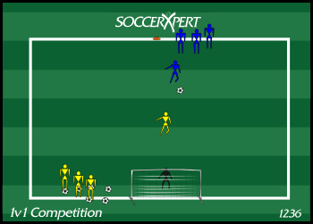](http://www.soccerxpert.com/printdrill.aspx?id=1236)

**Setup**



Split the team into 2 groups with each group wearing alternate jerseys with a keeper in the goal. Place a cone about 25 years from the goal. 1 team defends by the goal, and the other team attacks by starting at the cone 25 yards from goal. Each team plays for 5 minutes.

**Instructions**

The 1st defender plays a ball into the 1st attacker and steps out to defend. The attacker attempts to beat the defender and a point is awarded to the attackers team for each goal that is scored. After a goal is scored, or the defensive player wins the ball, the next defender plays a ball into the next attacker and play continues. Each team attacks for 5 minutes and defends for 5 minutes. The team with the highest goal count wins. Play 2 games awarding a winner after each match. If each team wins a match, play another round to break the tie.

**Variations**

* Play 2v2
* make players "beat" the defender before shooting (no 25 yrd bombs)

**Coaching Points**

**Offensive:** Attack defender with speed, quick explosion to get away, try to get behind the defender, and shoot at any half-chance.  
**Defensive:** Close down quickly, force the attacker to the weak side, break down, and close the attacker down. Remember Fast, Slow, Outside, Low. Fast - approach the attacker with speed. Slow - when the defender gets close to the attacker, the defender must slow their run and start stepping back with the attacker. Outside - force the attacker to the outside. Low - low center of gravity and get player low.

**3v1 Early Support**

This soccer drill focuses on supporting the player with the ball including early support, moving without the ball, and good angle and distance of support.

[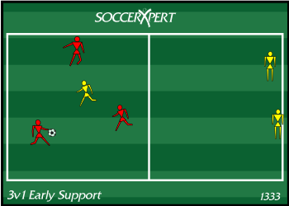](http://www.soccerxpert.com/printdrill.aspx?id=1333)

**Setup**



Create two 12X12 grids with one common side. Split into 2 groups of 3 players (3 red and 3 yellow). Place3 red and 1 yellow player in one grid and the remaining 2 yellow players in the other grid.The single yellow player in the red grid will start as defender.

**Instructions**

Play a 3v1 in the first grid, focus on **early support**, **good angles**, **good distance**, and **giving the player with the ball two passing options**.

The defender's objective is to gain possession and pass to a player on their team in the other grid. If this happens, that defender joins his team in the grid and the person who caused the turnover also joins the grid and becomes defender. In the new grid play 3v1 again.

**Variations**

* limit the number of touches

**Coaching Points**

1. **Early support** - start supporting before the ball is received.
2. **Good angle** - support in undefended space where the pass cannot be intercepted by the defender.
3. **Move without the ball**
4. **Support both sides of the attacker** with the ball.
5. Focus on a **good first touch in space** towards a supporting player.
6. Use deception when playing.

**4v2 Angle of Support**

This 4v2 soccer game will help perfect early support, movement without the ball, and good angle and distance of support.

[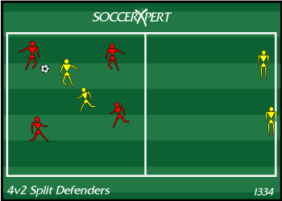](http://www.soccerxpert.com/printdrill.aspx?id=1334)

**Setup**



Create two 18X18 grids with one common side. Split into 2 groups of 4 players (4 red and 4 yellow). Place 4 red and 2 yellow players in one grid and the remaining 2 yellow players in the other grid. The 2 yellow players in the red grid will start as defenders.

**Instructions**

Play a 4v2 in the first grid, focus on early support, good angles, good distance, and giving the player with the ball at least 2 passing options at all times.

The defender's objective is to gain possession and pass to a teammate in the other grid. If this happens, that 2 defenders join their team in the new grid. The person who caused the turnover along with one other teammate joins the new grid as defenders. Play 4v2 and repeat this pattern.

This game should be very dynamic and players should be moving at all times. Even the players waiting in the opposite grid should be moving to put themselves in a good supporting role.

**Variations**

* limit the number of touches

**Coaching Points**

* Early support - start supporting before the ball is received.
* Good angle - support in undefended space where the pass cannot be intercepted by the defender.
* Move without the ball
* Support both sides of the attacker with the ball.
* Focus on a good first touch in space towards a supporting player.
* Use deception when playing.

**Split the Defenders Passing Game**

This soccer drill is great for a little more advanced player from 11 years old to 14 years and focuses on passing to split two defenders.

[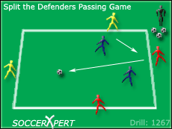](http://www.soccerxpert.com/printdrill.aspx?id=1267)

**Setup**



Make a grid approximately 18x18 yards. Split team into three teams of two players per grid. Build multiple grids for additional games.

**Instructions**

2 teams work together on the outside of the grid while the 2 defenders work on the inside of the grid. The four players on the outside keep possession and keep the ball from the defending team in the grid. The outside team scores a point when the ball is passed between two defenders (SPLIT) and is received by their teammate across the grid.   
  
If a player on the attacking team makes a mistake, he and his partner become the defenders and the team winning the ball comes outside the cones and joins the other attackers.  
When the defensive team gets split, they have to win the ball 1 extra time. So for example, say the 2 defenders get split 2 times before winning the ball, they must win the ball 3 times before switching with the attackers.

**Variations**

* Limit the number of touches per possession
* Play the same game, but expand the grid 3-5 yards on all sides and have the players play inside the grid instead of outside the grid.

**Coaching Points**

* Make sure the attacking players are moving for their partners and opening up in space.
* Make sure balls are passed with good pace and on target
* Encourage players to communicate verbally and with their body and hands

**Angle of Support Possession Drill**

This soccer passing drill is a great drill for teaching young players angle of support and spacing.

[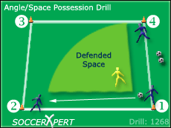](http://www.soccerxpert.com/printdrill.aspx?id=1268)

**Setup**



Set up a grid that is 10 X 10 yards. Organize the team into groups of three players per grid. Each of the three players should position themselves near 3 different corners of the grid with one ball.

**Instructions**

The instructions are simply to never leave an empty cone adjacent to the player with the ball. For example, say the drill begins with a player at position 1 in possession of the ball while players at 2 and 4 start at the cones adjacent to the player at 1. The player at position 1 can pass to either of the players at positions 2 and 4. If the player at position 1 passes to the player at position 2, the player at position 4 must quickly move to position 3 in order to support the player in “un-defended space”. The play continues with no defensive pressure and players are allowed to pass to either supporting player. This soccer drill is simple, however, players will have to pay attention to the ball movement and often anticipate the next move in order to move to space quicker.

**Variations**

* Play in 1 or 2 touches.
* Add a defender

**Coaching Points**

* Make sure players are thinking and moving quickly to the next supporting position.
* Explain Defended Space (see diagram)
* Help players with good angle of support

**Down and Back Dribbling Game**

This drill is most effective with young players just learning to dribble. This drill teaches players to dribble in high traffic/high pressure situations while staying in control. It's a great warm-up to focus on dribbling with all parts of the foot.

[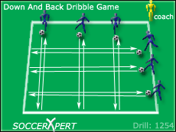](http://www.soccerxpert.com/printdrill.aspx?id=1254)

**Setup**

Start by making a grid approximately 20X20 yards. Split the team into two groups. Each player should have a ball. Instruct each group of players to line up outside the grid facing inward on two adjacent sides of the grid (half of the group on one side, the other half on the side next to the other group).

**Instructions**

On the coaches command, instruct the players to dribble to the other side of the group and back to the starting position (down and back). The first player back in each group gets a point. The first player to 5 wins that set. Play 3-4 sets.

**Variations**

- restrict players to touches with a certain foot or part of the foot. (example: left foot only, or outside of the foot only)  
- Have the player turn or cut when they reach the opposite side of the grid  
- Place even groups on all four sides of the grid and play the same game. - Make the grid a bit larger and have the players dribble with speed

**Coaching Points**

- focus on the players getting their heads up while dribbling for awareness and to avoid collisions  
- make sure players keep the ball at a close/safe distance. If the ball is too far in front of them they will most often hit another player or lose their ball.

Jam-Packed Dribbling Drill

This [soccer dribbling drill](http://www.soccerxpert.com/drills.aspx) will give players confidence while dribbling through congested areas on the soccer field.

[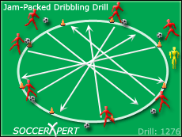](http://www.soccerxpert.com/printdrill.aspx?id=1276)

**Setup**



To begin this drill, create a circle with disc cones that is approximately 20 yards in circumference. Make sure each player has a ball, and instruct them to line up around the outside of the circle.

**Instructions**

Have the players begin the soccer drill by dribbling around the outside of the circle all in the same direction. The coach should inform the players to listen for certain queues and perform those actions once the coach shouts the command. These commands are:

* JOG - players should dribble at a comfortable speed
* FULL SPEED - players should dribble at their top speed
* CUT - players should cut the ball in the other direction and travel in the other direction around the circle
* CROSS - all players should cut across the grid avoiding contact with other players or other players balls.

**Variations**

Think of other commands to add to the drill.

**Coaching Points**

* Since all 4 players should be entering the center area at the same time make sure players are looking ahead of them with their head up.
* Remind players to keep the ball close when entering the traffic area.
* Have players start playing with their arms up and out for balance and shielding
* Instruct players to dribble with both feet and all parts of the foot.
* This is a fun soccer drill, so make sure to HAVE FUN!

**Attack vs. Defence Shooting and Defending Drill**

This drill is one that the kids love. The players will get to work on both attacking (shooting) and defending skills and if ran correctly, very fast paced.

[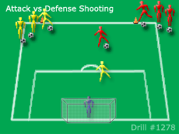](http://www.soccerxpert.com/printdrill.aspx?id=1278)

**Setup**



Create a grid that is as wide as the penalty box, and approximately 25-30 yards from goal. Place a goalkeeper in the goal and split the remaining players into two groups (Red and Yellow). The two groups will line up on opposite sides of the file on the cone set farthest from the goal. Make sure that every player has a ball.

**Instructions**

On the coach’s command, the first player in the Red group dribbles the ball with speed at the edge of the penalty box and quickly has a shot as they approach. Immediately after the Red player shoots, the first player from the yellow group dribbles at the penalty box as the Red player defends his attempt. After the Yellow player shoots, they immediately defend the next red player who is now attacking. Repeat this rotation throughout the drill.

**Variations**

NONE

**Coaching Points**

**Attacking:**

* Make sure the attack is quick, controlled and the player gets the shot off quickly
* Put the shot on target even when under pressure.
* Dribble with speed.

**Defending:**

* Transition Quickly from Offense to Defense